Practical 4

Natya Vidhan Biswas
B.Sc. (H) C.S. 25771

Same program, Same code
#include <stdio.h>
#include <unistd.h>
#include <sys/types.h>

int main() {
pid_t pid;
pid = fork();

if (pid < 0) {
perror("Fork failed");
return 1;
}
printf("Process ID: %d, Parent ID: %d\n", getpid(), getppid());

return 0;
}

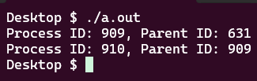

Same Program, Different Code
#include <stdio.h>
#include <unistd.h>
#include <sys/types.h>

int main() {
pid_t pid;
pid = fork();

if (pid < 0) {
perror("Fork failed");
return 1;
}

if (pid == 0) {
printf("Child: My PID is %d\n", getpid());
} else {
printf("Parent: My PID is %d, Child PID is %d\n", getpid(), pid);
}

return 0;
}

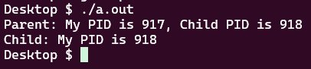

Parent Waits for Child
#include <stdio.h>
#include <unistd.h>
#include <sys/types.h>
#include <sys/wait.h>

int main() {
pid_t pid;
pid = fork();

if (pid == 0) {
printf("Child: Executing 'ls' command\n");
execlp("ls", "ls", "-l", NULL);
} else {
int status;
wait(&status);
printf("Parent: Child finished. Now parent continues.\n");
}
return 0;
}

